Chapter 1
INTRODUCTION
Rapid urbanization and increasing waste generation have made conventional waste management systems inefficient, leading to poor segregation, environmental pollution, and improper disposal which contain toxic chemical and health hazards. To address these challenges, the Smart Waste Segregation System mechanisms to automatically segregate waste, , and safely This system reduces manual intervention, improves hygiene, promotes recycling, and ensures environmentally responsible waste handling, making it suitable for public places, institutions, and smart city applications while contributing to sustainable and cleaner surroundings.

  - Brief history of waste segregation
Waste management practices have evolved from simple open dumping and manual disposal methods in early civilizations to organized collection systems during industrialization, driven by increasing urban populations and public health concerns. The introduction of waste segregation and recycling gained importance in the late 20th century with growing environmental awareness, while technological advancements led to the use of sensors, automation, and smart bins in modern waste management. Recent developments focus on integrated systems that not only segregate waste but also address associated issues such as reflecting a shift toward intelligent, sustainable, and smart city–oriented waste management solutions.

  - Modern waste segregation
Modern waste segregation utilizes smart technologies such as sensors, microcontrollers, IoT, and automated sorting mechanisms to efficiently separate waste at the source into biodegradable, recyclable, hazardous, and special categories .These systems reduce human intervention, improve recycling efficiency, and minimize environmental pollution by ensuring proper handling of waste. By integrating real-time monitoring, data analytics, and additional features and safety mechanisms, modern waste segregation plays a crucial role in maintaining hygiene, supporting sustainability, and enabling smart city waste management solutions.

Chapter 2
Problem Statement
2.1 Description
The absence of an efficient and automated waste management system leads to improper waste segregation, increased environmental pollution, in public and institutional areas. Existing manual systems are unhygienic, labor-intensive, and ineffective in managing mixed waste, resulting in poor recycling efficiency and health hazards. Hence, there is a need for a smart waste segregation system with ensure hygienic, sustainable, and environmentally safe waste disposal.
2.2 Challenge Statement
The key challenge is to design and implement a cost-effective, reliable, and automated system that can accurately segregate different types of waste. The system must operate with minimal human intervention, maintain hygiene, withstand varying environmental conditions, and be suitable for deployment in public and institutional spaces while ensuring sustainability and ease of maintenance.

Chapter 3
3.1 Design Thinking Process
1.Empathize:
Understand the problems faced by people due to mixed waste.
2. Define:
Define the problem as the need for an automated system to segregate waste, and to improve hygiene.
3. Ideate:
Generate ideas to use sensors, automation, mechanisms to create a smart waste management solution.
4. Prototype:
Develop a working model using sensors, microcontroller, motors, and compartments to demonstrate automatic segregation
5. Test:
Test the system in real conditions to check accuracy, reliability, and effectiveness in waste segregation.

3.2 Methodology
1. Working Principle (Overview)
The system is designed to:
Automatically segregate waste (wet, dry, metal)
It uses sensors, microcontroller, motors, and modules to perform all actions without human contact.

2. Components Used (Typical)
1.IR Sensor / Ultrasonic Sensor – Object detection
2.Moisture Sensor – Wet waste detection
3.Metal Sensor – Metal waste detection
4.Servo Motors – For opening flaps
5.Buzzer / Spray Module – Pest control
6.Microcontroller (Arduino / ESP32)
7.Separate compartments (Wet, Dry, Metal)

3. Working Procedure (Step-by-Step)
Step 1: Waste Detection
When waste is dropped into the inlet, an IR/Ultrasonic sensor detects the presence of waste and signals the microcontroller.

Step 2: Waste Type Identification
The system checks:
Moisture Sensor → detects wet waste
Metal Sensor → detects metal objects
If none → considered dry waste

Step 3: Segregation Mechanism
Based on sensor data, the microcontroller:
Rotates the servo motor
Opens the corresponding compartment flap
Drops the waste into the correct bin:
*Wet bin
*Dry bin
*Metal bin

Step : System Reset
After waste disposal :
System resets
Ready for next waste input

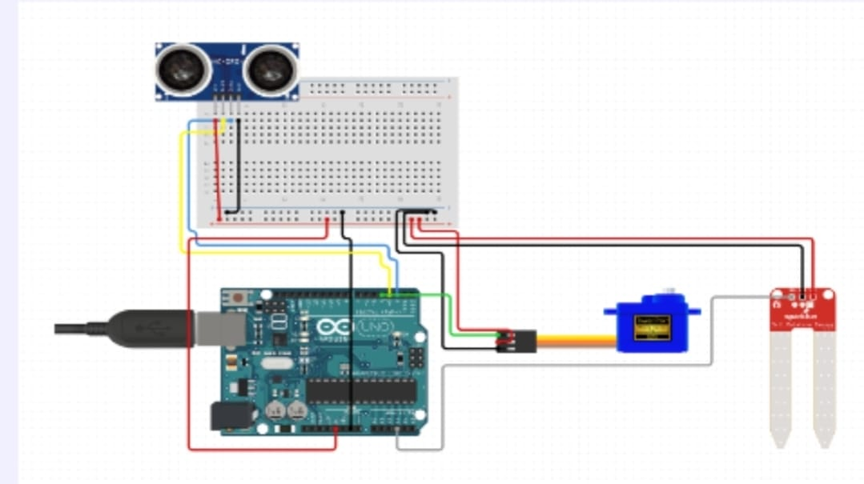

3.3.1 System Diagram
┌───────────────┐
│ Power Supply │
└───────┬───────┘
|
v
┌────────────────┐
│ Microcontroller│
│ (Arduino / ESP32)│
└─────┬─────┬─────┘
| | |
┌───────────────┘ | └───────────────┐

┌─────────────┐ ┌─────────────┐
│ Moisture │ │ Metal Sensor│
│ Sensor │
└──────┬──────┘ └──────┬──────┘
| | |
Wet Waste Metal Waste
Bin Motor Bin Motor Bin Motor

┌─────────────┐
│ IR / Ultrasonic│
│ Sensor │
└──────┬──────┘
|
Waste Detection

┌─────────────┐
│ PIR / Camera│
│ Sensor │

* Block Diagram Description
*Power Supply: Provides 5V/12V to all components.
*Microcontroller: Brain of the system. Takes sensor input & controls motors.
* IR/Ultrasonic Sensor: Detects waste entry.
* Moisture Sensor: Identifies wet waste.
* Metal Sensor: Detects metal objects.
* Servo Motors: Direct waste into correct compartment.
* PIR / Camera Sensor: Detects pests.

2. Circuit Connection Diagram (Text Explanation)
* Sensor Connections
* Component are:
1.Arduino Pin IR Sensor :D2
2.Moisture Sensor :A0
3.Metal Sensor :D3
4.PIR Sensor :D5
5.Servo Motor 1 (Wet) :D6
6.Servo Motor 2 (Dry) :D7
7.Servo Motor 3 (Metal) :D8

Chapter 4
Implementation
#include <Arduino.h>
#include <NewPing.h>
#include <Servo.h>

// ---------------- PIN DEFINITIONS ----------------
#define TRIG_PIN 3
#define ECHO_PIN 2
#define SERVO_PIN 4
#define MOISTURE_PIN A3

// ---------------- OBJECTS ----------------
NewPing sonar(TRIG_PIN, ECHO_PIN, 30); // Max distance 30 cm
Servo wasteServo;

// ---------------- SERVO POSITIONS ----------------
const int DRY_POSITION = 20; // Dry waste side
const int WET_POSITION = 150; // Wet waste side

// ---------------- MOISTURE THRESHOLD ----------------
int moistureThreshold = 500; // Adjust after testing

void setup() {
Serial.begin(9600);

wasteServo.attach(SERVO_PIN);
wasteServo.write(DRY_POSITION); // Default dry
delay(500);
}

void loop() {

int distance = sonar.ping_cm();

if (distance > 0 && distance < 10) { // Waste detected
Serial.println("Waste detected");

int moistureValue = analogRead(MOISTURE_PIN);
Serial.print("Moisture Value: ");
Serial.println(moistureValue);

if (moistureValue < moistureThreshold) {
// -------- WET WASTE --------
Serial.println("Wet Waste");
wasteServo.write(WET_POSITION);
}
else {
// -------- DRY WASTE --------
Serial.println("Dry Waste");
wasteServo.write(DRY_POSITION);
}

delay(1500); // Time to drop waste
wasteServo.write(DRY_POSITION); // Reset position
delay(2000);
}
}

Chapter 5
Results and Analysis
User Testing & Feedback
Sample:
Participants: 12 students and 2 faculty members.
Quantitative Results:
- - Scan time reduced to 1.4 seconds.
- - Queue time reduced from 10 minutes to 1 minute.
- - Accuracy: 100% during testing.
Qualitative Feedback:
- - Students: “Much faster than existing device.”
- - Faculty: “Live dashboard is extremely helpful.”
- - Admin: “No data mismatches during testing.”

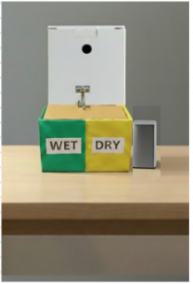
The smart waste segregation system uses sensors and a microcontroller to automatically detect and separate wet and dry waste through a motorized mechanism.. The system delivers accurate waste segregation with minimal human involvement, reduces waste mixing, improves hygiene, and lowers pest-related health risks. Overall, it enhances cleanliness, promotes responsible disposal practices, and supports efficient and sustainable waste management in public and residential spaces.

Chapter 6
Conclusion & Future Work
The Smart Biometric Attendance System effectively addresses inefficiencies in traditional attendance methods. It enhances accuracy, reduces time wastage, and improves administrative transparency.
Future Work:
- AI‑based facial recognition.
- Predictive absentee analytics.
- Automated parent notifications.
- Full ERP/LMS integration.

References
Research Papers
- Michael J. Folk, Bill Zoellick, Greg Riccardi: File Structures-An Object Oriented Approach with C++, 3 rd Edition, Pearson Education, 1998.
- K.R. Venugopal, K.G. Srinivas, P.M. Krishnaraj: File Structures Using C++, Tata McGraw-Hill, 2008.
- Raghu Ramakrishan and Johannes Gehrke: Database Management Systems, 3 rd Edition, McGraw Hill, 2003
Text books
- http://faculty.kfupm.edu.sa/ICS/saquib/ICS202/Unit29_Hashing2.pdf

- http://interactivepython.org/runestone/static/pythonds/SortSearch/Hashing.html
Online articles
- https://en.wikipedia.org/wiki/Quadratic_probing

- http://research.cs.vt.edu/AVresearch/hashing/collision.php

Annexures
Annexure A – User Feedback Forms
Annexure B – Iteration Notes
Annexure C – Team Roles

